Christian Assembly Newsletter September 2018

# **敬畏上帝**

-Jeanette Chia 姐妹分享

我们为什么要敬畏上帝？不是浑身颤抖的那种害怕，而是对全知全能的上帝神圣的敬畏。上帝是配得崇敬和敬拜的。圣经诗篇130:4告诉我们说“但在你有赦免之恩，要叫人敬畏”。除了全能的上帝谁能赦免罪呢！他已经战胜罪、撒旦、死亡和地狱。诗人告诉我们说：“他把整个世界握在自己的手中。他将大地悬于虚空之上。”上帝掌管一切。

**要敬畏耶和华，远离恶事 （箴言3:7）**

在上帝眼中，没有罪恶。任何罪恶都不能进天堂。诗篇97:10说到：“你们爱耶和华的，都当恨恶罪恶。”任何污秽和不洁不能进天堂。他的眼目圣洁不看邪恶。启示录21:5说到：“看哪，我将一切更新了。”在新耶路撒冷，也就是新天新地，所有一切都是圣洁公义的。“敬畏耶和华，在乎恨恶邪恶”（箴言8:13）。“耶和华的道理洁净，存到永远”（诗篇19:9）。耶和华乃是行正路人的要塞，因为人所行的道在上帝的眼前。“他也修平人一切的路”（箴言5:21）。“神道成肉身使恐惧终结”-E.B. Meyer。敬畏耶和华的人，是有福的。恐惧使我们软弱，但是信仰激励我们跟随主。当我们被恐惧压倒的时候，让我们投向主，因他是我们的避难所，我们的力量。在主里面没有恐惧。忠心的人满了祝福。

**敬畏耶和华，就是生命的泉源 （箴言 14:27）**

泉源乃是水不断流出的所在。耶和华乃是生命的泉源。他永远长存。“敬畏耶和华使人的日子加多”（箴言10:27）。十诫第五条诫命告诫我们“当孝敬父母，使你的日子在耶和华你神所赐你的地上得以长久”（出埃及记 20:12）。你的父母将你带到这个世界，关心你，并且努力工作教育你养育你，他们不应被忽视。当你长大开始工作后，轮到你去关心他们，在他们年老的时候孝敬他们。这是神的诫命，我们须顺服他。“耶和华的命令清洁，能明亮人的眼目”（诗篇19:8b）。

“敬畏耶和华的，大有倚靠”（箴言14:26）。“耶和华喜爱敬畏他的人”（诗篇147:11）。“敬畏耶和华的，得着生命，他必恒久知足，不遭祸患”（箴言19:23）。相信耶和华的没有恐惧，因他们信仰上帝，上帝保守他们。

**敬畏耶和华是智慧的开端 （箴言1:7）**

雅各书1:5告诫我们说：“你们中间若有缺少智慧的，应当求那厚赐与众人、也不斥责人的神，主就必赐给他”。但是你必须凭信而求没有任何疑惑。谨记神不看外在，而是看内在-也就是你的心。

将智慧用于我们的日常生活中，是一个非常实际的问题。在不幸的日子里，我们需要用神的保护、智慧和洞察力去回应周围扭曲人的诡计，解决你所爱的人的麻烦。从我们的生活中挪去恐惧，将你的信任托付给永生的神。“所积蓄的一切智慧知识，都在他里面藏着”（歌罗西书2:3）。所以，我们需要小心地，有智慧地在这个堕落诡诈的世界明智地生活。我们需要警醒并小心陌生人。在我们遇到不确定的情况时需要主的保护，他让我们远离罪恶。我们要常常祷告。上帝是远方的一个祷告者。他是可亲近的，他是亲爱的，他会倾听。信心就是在黑暗中也要相信主。他非常爱他的子民。

从我们的生活中挪去恐惧，将你的信任托付给永生的神。“永生的神是你的居所，他永久的臂膀在你以下抱着你，支撑着你”（申命记33:27）。

**结论**

“这些事都已听见了，总意就是敬畏神，谨守他的诫命，这是人所当尽的本分。因为人所做的事，连一切隐藏的事，无论是善是恶，神都必审问” （传道书 12:13）。



*Notes and News*



**Wedding bells**

We rejoice with Bro. Daryl Pat and Sis. Beatrice Chua on their Holy Matrimony on 09 Aug 2018. May the Lord bless the newly wedded couple in their lives ahead!

**<May include thanksgiving sharing>**

**Thanksgiving**

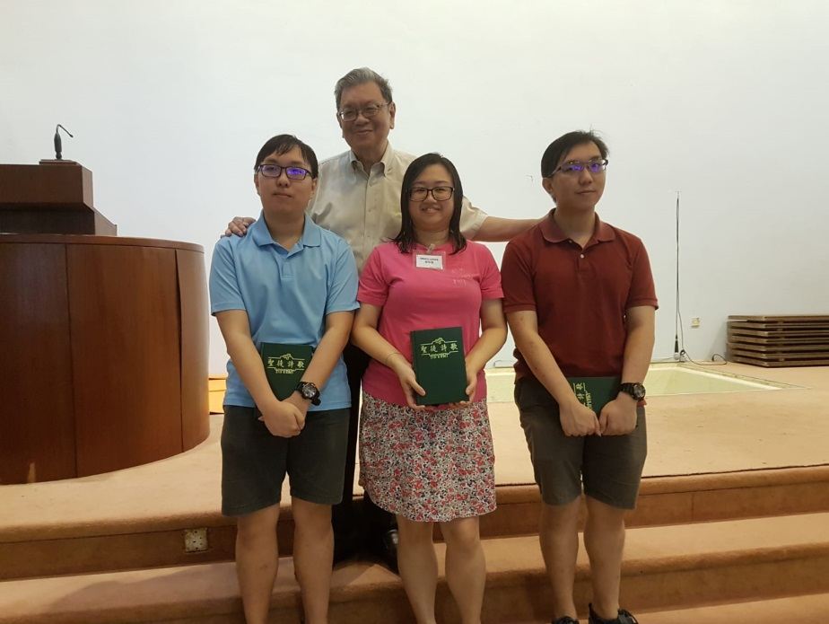Thank God for the three persons who got baptized on the 19th of August - two brothers, Yi Hao and Yi Wei and a sister (name). Continue to uphold them in prayer for protection and growth as they walk with our Lord Jesus and bear testimony to His name!

j0332982**Prayer items**

***Be careful for nothing; but in everything by prayer and supplication with thanksgiving let your requests be made known unto God. (Philippians 4:6)***

***And the peace of God, which passeth all understanding, shall keep your hearts and minds through Christ Jesus. (Philippians 4:7)***

*Watch and Pray*

**Pulpit ministry**

Commit the pulpit ministry in prayer :

* God will anoint the lips of His vessels and speak powerfully through them
* Speakers and translators to depend on God wholeheartedly to deliver His message in love and humility.
* Congregation to have prepared hearts, open ears and an obedient spirit to hear and to obey what the Lord says.
* Holy Spirit to speak to each of us to convict us, renew our minds and transform us to be more like Christ.

Speakers for the coming weeks are:

|  |  |  |  |
| --- | --- | --- | --- |
| **Date** | **Speakers** | | |
| **Wilkie** | **Asiawide** | **Gospel** |
| 02 Sep 2018 | Tan Yark Khwee | David Hung | Lim Boon Tiong |
| 09 Sep 2018 | Loh Sit Ming | Teo Ching Han |  |
| 16 Sep 2018 | Yeo Choon Guan | Sng Hock Heng |  |
| 23 Sep 2018 | Chua Meng Khiang | Tan Yark Khwee |  |
| 30 Sep 2018 | Tan Boon Guan | Yang En-Hua |  |

**Sunday School**

As we approach a new year, pray that:

* Sunday School Supervisors and teachers will seek the heart of God, to wait upon Him for His direction concerning the Sunday School
* Sunday School teachers to teach God’s Word faithfully with full dependence on God.
* Sunday School students to have a desire to study God’s Word, draw close to and have a personal relationship with God.
* Parents/guardians of Sunday School students to be faithful in bringing them to study God’s Word.

**Elders and deacons**

Pray for Elders & Deacons as they meet regularly concerning church matters:

* They may have the mind of Christ
* Come together in love and unity of the Holy Spirit
* Discern God’s will and direction for the church
* Decisions made will be pleasing to God.

**Missions**

Do commit the planning of upcoming missions to Malacca and Cambodia in prayer.

**Remember brothers and sisters in prayer, including those who are not well, elderly and those who are not able to attend church:**

* A big group of brothers and sisters from both Assemblies will be travelling to China - pray for protection, journey mercies and good fellowship in the Lord.
* **Bro Bobby Sng**
* **Bro Sng Hock Heng**
* **Sis Hee Aik**
* **Sis Ling Kam** who will be going for radiotherapy
* **Sis Irene Leong** who fell and hurt her wrist and hip.
* **Bro. Keen Mun’s mother**
* **Bro. Tan Song Seng** for recovery after a spine surgery
* **Sis Teo Siew Eng** has transferred to Lions Home for the elderly in Bishan and undergoing physiotherapy.
* **Sis Christina** has difficulty in breathing, and the right part of heart is failing
* **Mrs Wang Li Zhong and Mrs Lee** have weak legs
* **Others whom the Lord knows by name**

May the Lord comfort and strengthen them with His Presence & grace.

**Church ministries**

Your prayer support and involvement in any of the ministries would be an encouragement to the body of Christ.

“Now you are the body of Christ, and each one of you is a part of it.” 1 Corinthians 12:27

##### **Newsletter** … sharing of testimonies, pictures and articles to edify brothers and sisters

* **Transportation needs …** Pray for brothers and sisters to volunteer to serve as Gospel van drivers and for those with cars to give lifts to those in needs especially the elderly and the younger ones living in various areas.

**Note:**

Please note that prayer requests are reported up to the 3rd Wednesday of every month in order to prepare for translation and preparation for the printing of the newsletter, which will target to be available on the 1st Sunday of every month.

Those prayer items requested on the 4th Wednesday of every month, which is valid only for the following month, will not be reported because by the time the next newsletter is printed, these prayer requests would have been outdated. We thank all church members for their understanding.